CLOUDANT DB

**Creating Service Credentials:**

**Step 1**: To create the connection information that your application needs to connect the instance, click New credential.

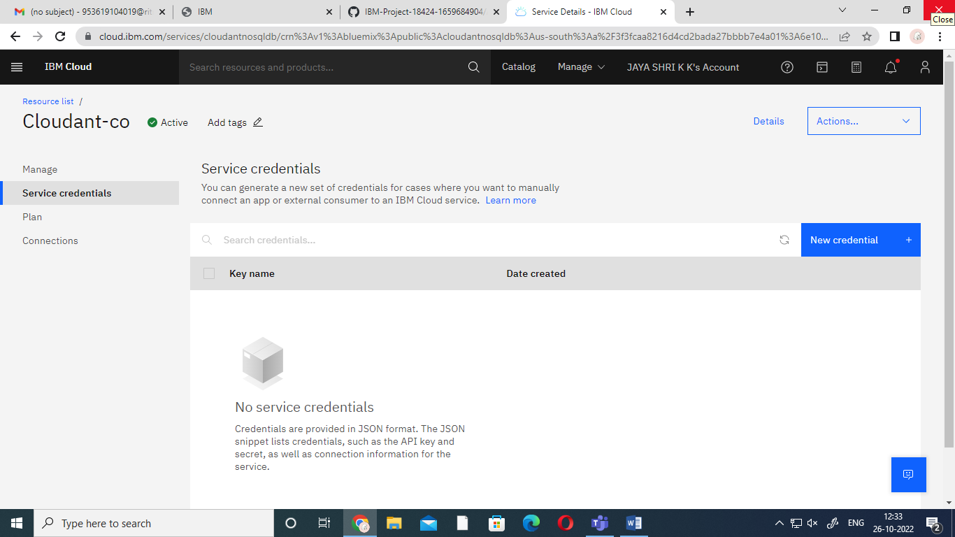

**Step 2**: Enter a name for the new credential in the Add new credential window.

**Step 3**: Accept the manager role and click **Add**.

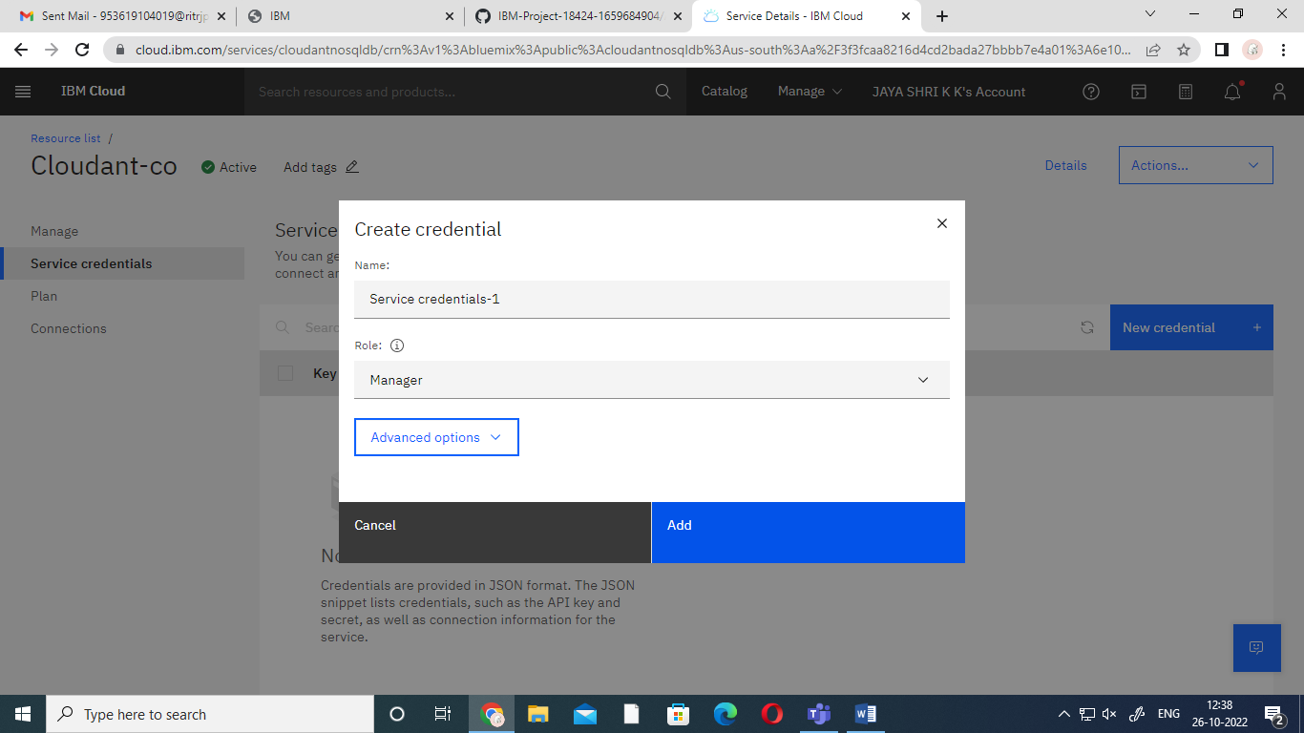

**Step 4**: To see the credentials that are required to access the service,click the chevron.

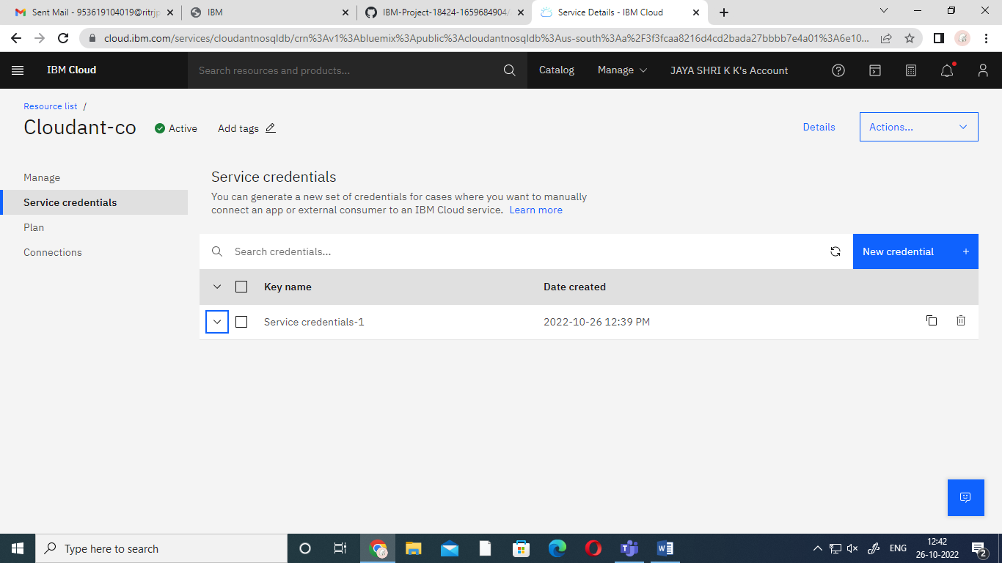

**Step 5**: The details of the service credentials open like the following example.

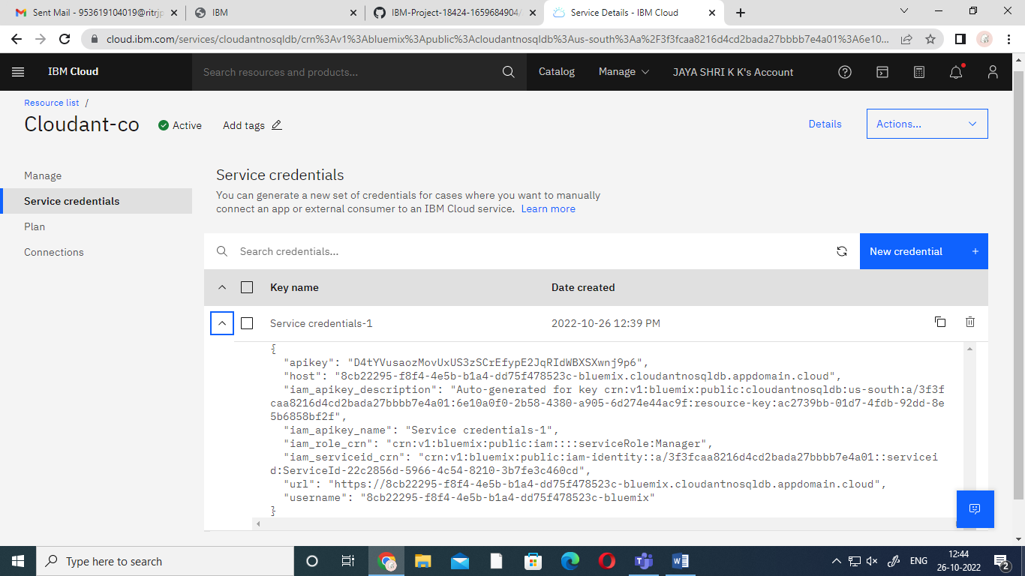

**Project By:**

**TEAM LEADER**

Muthuaruna C

**TEAM MEMBERS**

Jayashri K K

Malini M

Jayarani M